**[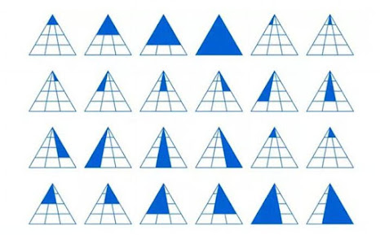](https://1.bp.blogspot.com/-4HtFgcrcuZ0/YJkFuFAFw-I/AAAAAAAAFQ0/bvsORrH2bWIBbZ7OHLiRczWLTVGNWMLtwCNcBGAsYHQ/s700/1501050399_how_triangles_02.jpg)**

**[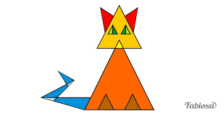](https://1.bp.blogspot.com/-mZCsC6iW85U/YJkFvZuQYII/AAAAAAAAFRA/gGWclUXIo1kHv8aQW0znYLXiDdd8RV-fwCNcBGAsYHQ/s311/images%2B%25281%2529.png)**

**[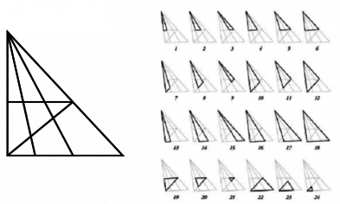](https://1.bp.blogspot.com/-U4fKkq-eFUM/YJkFvdrTUHI/AAAAAAAAFQ8/cZ06JppMGcIkJA0fEK5x2Z4OtBzT0WnZQCNcBGAsYHQ/s393/clicow_image_20170707142448-1-1-1-1-1-1-1-1-1-1-1.png)**

**[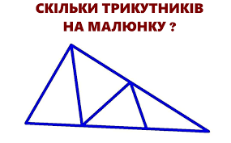](https://1.bp.blogspot.com/-0MbtcJcTXLM/YJkFvmu8d4I/AAAAAAAAFRE/_X-6HQHywhQ-ZwCvR8YBqhkn_WzPNb_tQCNcBGAsYHQ/s285/images.png)**

**[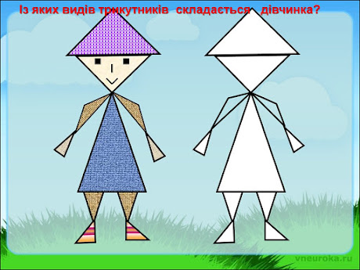](https://1.bp.blogspot.com/-gM7TDmRsJNw/YJkFv5c-3RI/AAAAAAAAFRI/MY13QurvNlMC5K05H-xRCFdRmmZVkPfJgCNcBGAsYHQ/s1024/slide-21.jpg)**

**[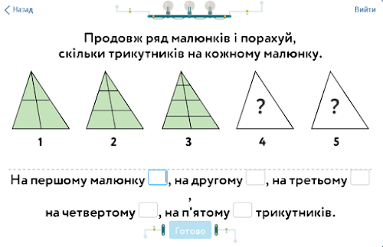](https://1.bp.blogspot.com/-7JTFQwnUJsA/YJkIEE6-d5I/AAAAAAAAFRo/jx4Jo0ktCu0B6NQbe0-g_izKK7OwrhUcQCNcBGAsYHQ/s800/87140043_acc91687d53626daefcfbd62092f410a_800.png)**

**[](https://1.bp.blogspot.com/-3-O3HS1LiCc/YJkIECRYdiI/AAAAAAAAFRk/8mqTsWki4Z4LQ6pV_h4PTGj4PAosH7fowCNcBGAsYHQ/s635/s-9458f8ab61b60d0864cf7d3bbb54cf0c38e6347d.jpg)**

**[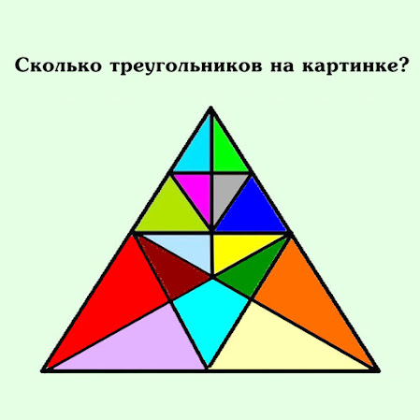](https://1.bp.blogspot.com/-OYnNFDM-wOY/YJkIENQ5_eI/AAAAAAAAFRg/75u8saRb7VUl8ZCRhDvy6_63E8GyWr9XQCNcBGAsYHQ/s1080/scale_1200.jpg)**

**[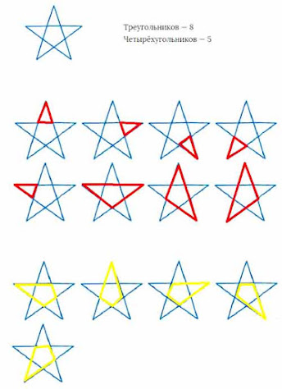](https://1.bp.blogspot.com/-xBliq0GmiLA/YJkIEmOm1ZI/AAAAAAAAFRs/E1GlxfA_iD43HNuCGmr9lpS9obzkRR5dwCNcBGAsYHQ/s512/unnamed%2B%25281%2529.jpg)**

**[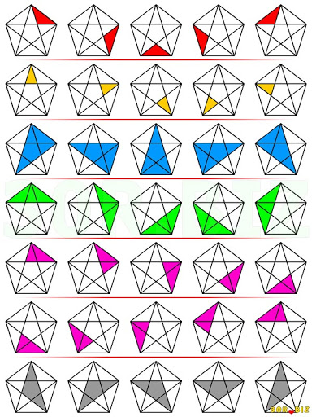](https://1.bp.blogspot.com/-EFQja2hzXqM/YJkIE43dJgI/AAAAAAAAFRw/2xiSTCHl-1EIku59m-TyS7gXy-CdWDClwCNcBGAsYHQ/s512/unnamed.jpg)**

**[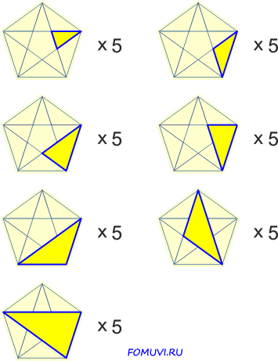](https://1.bp.blogspot.com/-loobYBKfG7Q/YJkIFJyhxyI/AAAAAAAAFR0/qki1vmi0RGMrWgBUgNHJ1X86YReJLtu5QCNcBGAsYHQ/s461/viewImage.gif)**